Purchase Order |  | 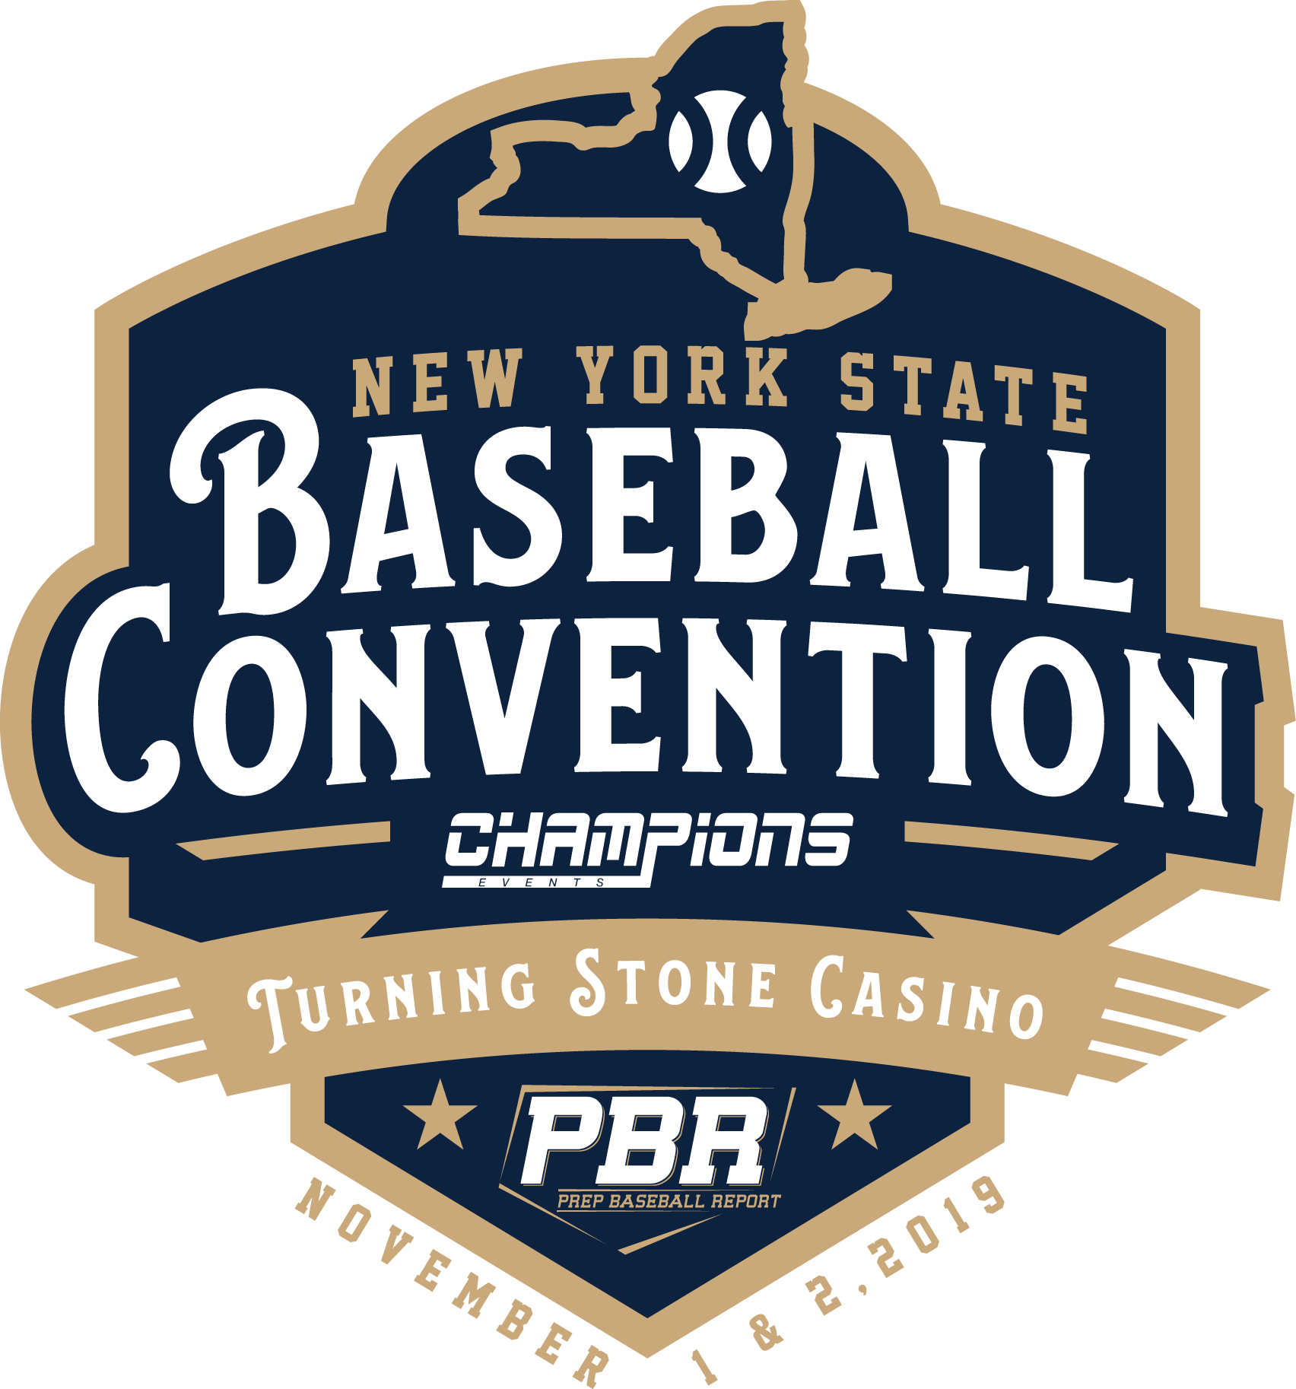
DATE  / /2019 | PO Number:  00____ | Presented by:  Champions Events  Prep Baseball Report-NY
School Name:

Address:

City, State ZIP:

2019 NEW YORK BASEBALL CONVENTION
November 1 - 2
Turning Stone Resort & Casino, Verona NY
ATTENDEE NAME | Description | TICKET PRICE ($99 each) | Line Total

____________________________ | Entry to 2019 NYBC | $99.00 | $ .00
____________________________ | Entry to 2019 NYBC | $99.00 | .00
____________________________ | Entry to 2019 NYBC | $99.00 | .00
Subtotal
Total
DUE ON RECEIPT
Make Checks Payable to:
CHAMPIONS EVENTS LLC
373 Spencer Street, Suite 101
Syracuse, NY 13204
(315) 430-0154
Info@ChampionsEvents.org
www.NYBaseballConvention.com

